Contact us:
sutherlandcommunitypartnership@gmail.com
Managing a project does not need to be complicated. This toolkit gives you some basic concepts and templates to help you plan and run your projects smoothly. The toolkit is based on our experience of managing community projects across Sutherland and the rest of Scotland.
Developed by the Sutherland Adaptive and Collaborative Communities Team, managed by the Kyle of Sutherland Development Trust in partnership with Sutherland Community Planning Partnership, and funded by the Aspiring Communities Fund from the Scottish Government and European Social Fund.

Introduction
Welcome to the Community Project Management Toolkit! Like all good toolkits, this document should be thought of as a set of tools that can be used together to fulfil a range of purposes. You do not need to use all of them for every project, and sometimes you can adapt them to suit a specific area of work. We hope these tools will make your role working on community projects easier, and allow you to move more quickly and efficiently.
Being part of a community places you in the perfect position to recognise when opportunities arise to help people in need, overcome challenges or to develop something new. The problem is, responding to opportunities or meeting a need often falls to voluntary efforts.
Convincing the funders and public agencies, that you might need to collaborate with, that you or your group can get the work done often hinges on how well you can present a plan at the early stages.
Even for the most organised among us, this can be a daunting task and so the Sutherland Adaptive and Collaborative Communities project team wanted to help break it down and share some tips on how to get started. We have managed projects of all shapes and sizes over the years and we have been trained in some of the well-known techniques. We know that these techniques can be like using a sledge- hammer to crack a nut when planning a modest community project. So, we have adapted what we know into some simple templates that are more appropriate to the type of projects usually managed by communities and volunteers.
The toolkit contains:
- Community Project Model
- Explanation of Project Roles and what they are for
- Section on who should be involved
- Setting objectives
- Suggested Project Stages
- Project Plan template
- Project Progress Report template
These materials are intended to simplify things like reporting and measuring successes and give you an idea of the people you need to get involved. Take whatever you need and what is appropriate for you. You do not have to use all the ideas and templates for every project.
Throughout the Project Management Community Toolkit we have used an example of developing a Community Garden project, we hope this project is relatable to communities across Sutherland and brings the toolkit to life for you.
We hope this toolkit will help you to show funders and partners that you are well prepared, but also that it will help make projects easier, reducing workloads and volunteer burnout.

Community Project Model
The hour-glass diagram below shows the Project Manager, the person who takes charge of organising everything, in the centre of two groups of people. The group of people who do the work are in the ‘Project Working Group’ and the people who have responsibility for, and oversight of the project are in the ‘Project Management Group’. Read more about the roles in each group in the next section.
The circles shaded blue indicate roles that need a level of ‘expert knowledge’ and the circles shaded orange indicate roles that need to understand ‘community need’. The green circle indicates ‘supporting’ roles.
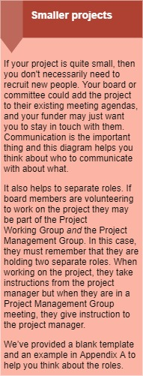
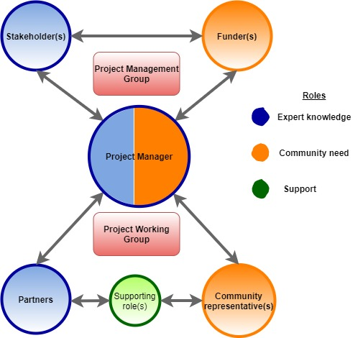

Expert Knowledge
The people in these roles are the experts in their area. From people with technical skills like website design or building development, to people with first-hand experience of living in a particular community or accessing or running a particular service, for example, a community garden. They might be highly qualified, traditional ‘experts’, like a professional gardener, or their qualifications might be lived experience of using what the project is trying to achieve, like working with local soils or landowners. They are essential because they can do or have knowledge of the technical side of the project.

Community Need
The people in these roles represent the community need or a particular demand. They have a good sense of why the project is needed based on experience, knowledge or evidence gathering in the case of funders. These people would understand the requirements of the community, to continue with the community garden example, what should be grown, who is likely to get involved and their specific needs. They may be a cross section of people from the community or representatives from additional community groups and organisations.

Supporting Roles
The people in these roles are those who will offer additional support to the project. They will not be required for all projects and can include those who may be recruited (paid or voluntary) to deliver the project. Examples of a Supporting Role may be a representative from another community sharing their experience of setting up a new community garden.

Project Roles

Project Management Group
The Project Management Group is the starting point of a project. They decide the best approach to get the best results. The buck stops with them, so they will want to know how any money is being spent, that the work is on schedule and if are there any problems. This Group is accountable for the project and the stages involved. We think it is helpful to think of all projects, big or small, in the following stages:
- Before you start
- Initial research
- Funded preparation
- Do the work!
- Finishing up
- Reflect
Read more about the Project Stages on page 7.

The Project Management Group is made up of the key stakeholders (e.g. your organisation’s board and representatives of other organisations you need to work with to get the work done) and the funders of the project. The Project Manager is appointed by the Project Management Group at the ‘Funded preparation’ stage. The group meet as often as necessary, there are no rules for how they should meet, just use common sense, and adopt a schedule appropriate to your project. If the project is very small, adding it to the agenda at ordinary meetings may be enough. If the project is quite big then consider having a separate Project Management Group meetings (which may just be a sub-group of your board/committee). Funders may not want to attend regular meetings and may be happy to have a regular email or phone call updates.

Funder(s)
For projects which require financial support the Funder (or sponsor) must be identified at the ‘Initial research’ stage of project development (you should research funders whose objectives fit with yours at the ‘Before you start’ stage). It is important to build a relationship with the Funder to understand their wishes and to reach an agreement on how you will get your results with their financial support. This will save time in the long run. Funders want your project to succeed but they must ensure their money is spent responsibly and so they will aim to strike a balance. Make sure any issues that might end up requiring extra resource or budget are raised as soon as possible and involve them in decision making.

Stakeholder(s)
The Stakeholder(s) are the core strategic decision makers for the project, including your own organisation. They are the people who will make a commitment to work together to get the best results possible and achieve the outcomes promised to the community and the funders. Stakeholders may be from all sectors – public, private or third. The Stakeholders will help interpret the needs of the Funder and communicate these to the Project Manager and provide strategic direction for the project. Stakeholders will include the manager or chair or equivalent of an organisation; officers from public sector agencies; or representatives from private businesses for example. These individuals have a non-financial a ‘stake’ in the project.

Project Manager
The Project Manager is the core link between the Project Management Group and the Project Working Group. We recommend this role is assigned to just one person, rather than shared between several people, as this can lead to confusion, makes work harder to coordinate and slows everything down. Appointed by the Project Management Group the role of the Project Manager can be a paid or voluntary position, but the important thing is they are empowered to lead the work and make decisions. They are responsible for making sure the project does what it sets out to do and that everything is completed on time and within budget. The Project Manager will lead the strategic and practical directions of the project. They make day to day decisions and manage any Project Officers if the project requires them. The Project Manager reports progress to the Project Management Group and is actively involved in the Project Working Group.

Project Working Group
This is the group responsible for doing the practical work to turn ideas from the Project Management Group into reality. They plan the day-to-day detail together. The Project Manager provides the main link between the Management Group and the Working Group and leads the Working Group.Identifying more people to form the Project Working Group is not always necessary for every project, smaller projects may identify representatives from the Project Management Group to make up a Project Working Group.

Partner(s)
This is an expert role and can be held by more than one person if required. Partners at this level are often potential service users themselves and understand how the project output will be used and have the technical skills to develop it. Working Group Partners can be volunteers, paid staff or paid consultants. They help ensure that the project output will be technically correct or fit for purpose. In the case of a community garden, Partners may be gardeners, volunteer managers or architects.

Community Representative(s)
This is a community needs-based role and can be held by more than one person if required. Community representatives can be volunteers or paid staff to the project. They have lived experience of the community; represent its needs and help to ensure that the project output will get the right results. For example, someone who can link the community garden to tackling social isolation issues or family and youth activities.
Supporting Role(s)
Supporting roles can be paid staff, volunteers or paid consultants who will join to do something specific or occasional, such as a trainer, advisor or workshop facilitator. Supporting roles are not essential to every project and will be dependent on the project resources available such as funding. Supporting Role representatives can be guests invited to a one-off meeting. If short-term project officers are needed for a specific piece of work, they will be involved in the Project Working Group in a Supporting Role.

Setting Objectives
As soon as you have an idea for a project, consider your objectives. These are the steps you need to take on the road to achieving your idea. How do you get from that idea to create a community garden, to pulling out your first tattie? Sometimes it helps to work backwards to identify the steps, and sometimes the steps only become clear once you start down the road. Either way, objectives need to be SMART, and funders will recognise this way of thinking about them. So, for each objective or step, consider the following:

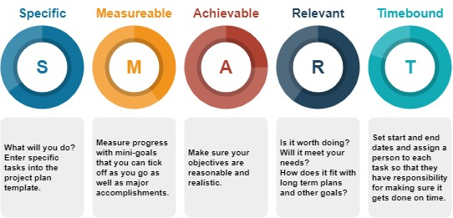

You might find some funders are looking to see you have considered the environment or the three pillars of sustainability (people, planet and profit). Do people buy into your objectives? Will your objectives have any (positive or negative) economic or environmental impacts?

Try www.planetsutherland.com for ideas on environmental impacts.

Project Stages
All community projects begin with a need, challenge or opportunity but moving from recognising these to doing something tangible to bring about change usually follows a process which has been broken down in the project stages diagram below.
Using the Checklists under each of the headings will help to demonstrate that you have considered all Project Stages. You do not have to tick everything, just do what is relevant for you and your project.
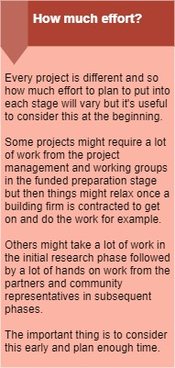
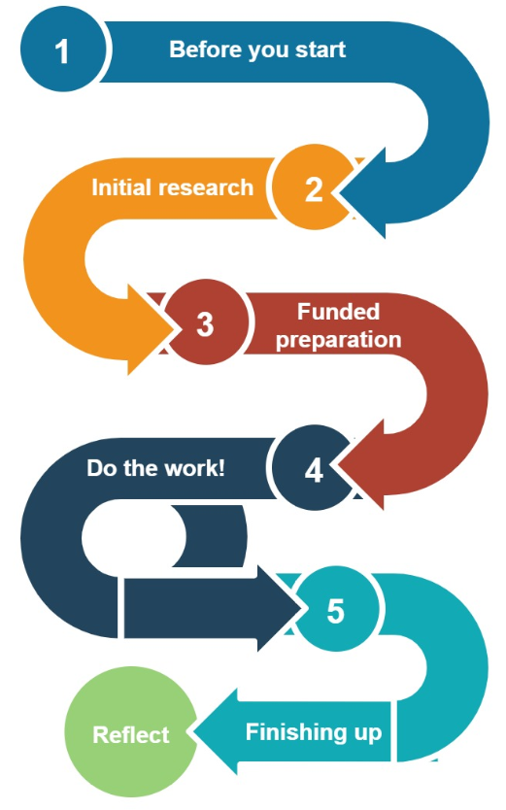

Before you start
All projects start with an idea. At this stage check whether the project is worthwhile and if the effort and anticipated costs of the next stage justify the outcomes.
Identify the challenge or opportunity. Make sure you can write this down clearly
Research potential funders and what funding is available if the project needs money
Consider a rough budget
Consider what options are available to bring about change
Consider what will happen if you do nothing
Identify who will make up the Project Management Group
Identify project outcomes, and initial objectives (see page 6), these will form the requirements that must be met before the project is signed off in the Finishing Up stage
Start to share your project idea
Use the Community Project Model template on page 1 to establish required roles and responsibilities

Initial research
Gather some evidence of the challenge or opportunity and get some initial quotes for any work that will need done. What is the situation today, gather proof, and how will this have changed at the end of your project? Consider if you can measure it, e.g. there is currently nowhere for families to meet and socialise outdoors. By the end of our project there will be four family gardening events each year. Many funders will not pay expenses that are incurred during this phase, so make sure you do not start the work yet!
Conduct research - for example community survey, Facebook polls, interviews or focus groups
Gather letters of support – this may include local politicians, community councils, other community groups, potential service users
Gather cost quotes and estimates if required
Identify potential project partners that will join the Project Working Group
Start to build relationships with potential funders
Apply for funding, remember to include a launch budget to celebrate your success, and maximise the number of people who are aware that the new service or product is available

Funded preparation
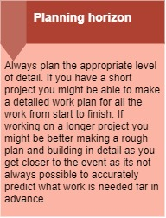
Once you have confirmed a funder, build firm foundations for your project.
Set up the Project Working Group: recruit the right staff and/or volunteers if needed
Plan the work. Agree on how you will know the project is finished. What are the essential requirements without which you cannot call the project complete? What are the non-essential ‘nice to haves’?
Consider how you can build in regular, detailed planning and reporting to the Project Management Group (including your funder) into your timescale. You can use the Project Progress Report template in Appendix C to get some ideas.
Get detailed costs and agree work with the Project Working Group
Create and confirm the project budget
The Project Management Group should create a Project Plan at the right level of detail, considering the planning horizon (see right).
Identify project risks, what might go wrong and how will you avoid this or prepare for it?
Agree Project Reporting timescales
Populate the Project Plan – use Project Plan template in Appendix B
Thoroughly consider and decide on your SMART objectives (page 6)

Do the work!
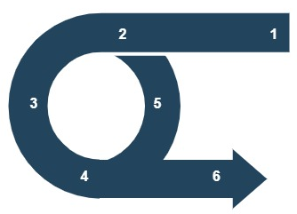
Even the best laid plans sometimes have to change, so plan how you will respond when things change. Test out what you are doing with the people who will end up using the project results. For example, show people plans for the community garden or invite people into the garden space and get them to walk around it, then respond to their feedback. Be prepared to go back and repeat work when you receive feedback from a test or review, this will ensure the project is fit for purpose. Report your progress regularly to the Project Management Group so that no one gets any big surprises when things do have to change.
u The Project Working Group (if you have one) creates a detailed Action Plan for the day-to-day tasks that need to happen to meet your SMART objectives. In this step, agree what tasks need carried out, and by who. Who will do the task is important, if there isn’t a person identified to do a job then that job won’t get done! Use the template on page 12 to help work this out if you need. Agree how you will know each task is finished. For example, is the task ‘order a tool-shed for the garden’ complete once you have placed the order, or when the shed physically arrives on-site? What is essential for the objective to be achieved (shed has a roof)? What is negotiable (shed has windows)? Do not forget to set deadlines for tasks.
v Get busy doing the work! Follow your Action Plan if you have one.
w Everyone involved with doing the work (the Project Working Group) should meet regularly to track progress, discuss obstacles, and celebrate successes. If you are working alone, identify a mentor from the Project Management Group to bounce ideas off.
x Test your work, create first drafts or proposed solutions, and run them by the people who will be affected by your project. This is where you might have a list of people who you want to check over your work. To continue the garden example, they may be invited to an open day to see how the garden is progressing. This is an opportunity to test whether wheelchairs can get around corners properly, or if there are any other observations that you can use to improve your designs.
y Be prepared to go back to the drawing board if drafts or solutions are not going to work once they've been tested.
z Leave some time to develop instructions or information for future development before you launch.
Create an Action Plan (use the Project Plan template on page 11, put in more detail for each task)
Agree how you will know each task is complete, so that everyone agrees that everything is done
Plan regular update Project meetings, identify and meet with a mentor if required
Schedule review and testing of your project work, leave time for a few different versions if what you are creating is complicated or controversial
Develop instructions or a report on how you did the work so that future improvements or developments can be easily carried out

Finishing up
Train any volunteers or staff in the use of what you have developed and supporting them to get going. Perhaps an orientation day for any new staff or volunteers to show them where everything is, how it works and what to do if there are any problems. This is the stage where the Project Management Group checks all the original objectives and agrees that the project is complete. Finally, launch your product, service, or whatever it is you have created!
Request permission to launch from the Project Management Group, once they agree all the requirements have been met.
Organise any training sessions
Launch your project! Organise an event, write a press release, set up an online webinar – use a format suitable to you and your project
Complete final reporting to Funder and Project Management Group

Reflect
In this stage, write up a final report, it does not have to be long but it is useful to reflect on whether the project achieved what it set out to do. Record what went well, and not so well. This is helpful for you and your funders to pass on best practice or lessons learned to other communities and to improve your next project, whether it is delivered by you, or your successors.
Ask everyone who worked on the project to give their insights and opinions
Write down your own opinions on how the project went
Revisit the measures that you set up in the Initial Research stage, have you achieved them?
Consider all the things that went wrong and why
Document all the solutions you found to challenges

Created by:

Sutherland Adaptive and Collaborative Communities (SACC) Project
The SACC project ran from August 2020 to April 2022. Embedded in the Sutherland Community Partnership and administered by the Kyle of Sutherland Development Trust, it’s primary aim was to tackle inequalities in Sutherland. Five areas, Creich, Golspie, Helmsdale, Brora and Kinlochbervie, had been identified as priority localities in Sutherland by the Community Partnership. Project staff supported these localities by helping to develop project ideas, funding proposals and creating a wellbeing website, resilience plans and this toolkit. The project was funded by the Scottish Government through the Aspiring Communities Fund.
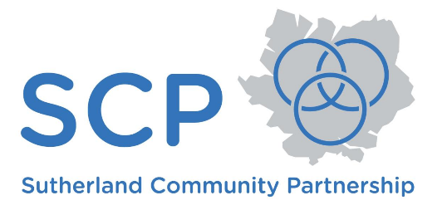

Appendix A: Blank Community Project Model

Based on the Project Roles descriptions contained within the Toolkit, consider who, or which organisation fits into each circle.
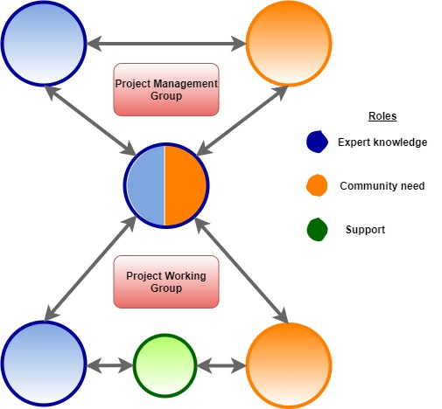

Example:
Helmsdale & District Development Trust identified that the community wanted to start a new growing initiative. Their ‘Project Management Group’ included the Trust, Timespan (where produce was eventually sold) and HIE through the Strengthening Communities directorate. The Trust’s treasurer coordinated the work, turning the aspirations of the Project Management Group into actions. They worked with an Engineer and Gardener to ensure the technical aspects of site selection and building (e.g. a polytunnel) were done well. Volunteers who also sit on the Trust board helped with the work and were able to input lived experience into the planning of the garden, adding raised beds and an accessible toilet to allow volunteers with reduced mobility to get involved. | 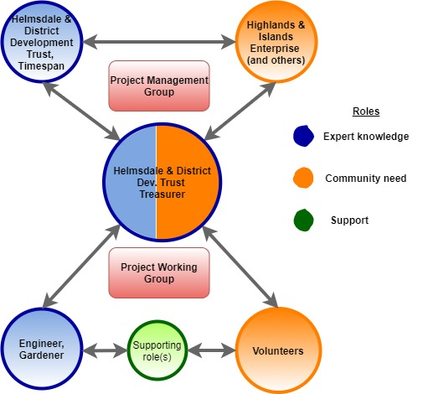

Appendix B : Project Plan template

What? | When? |  | Result | Measure | Who?
List each task you will need to carry out to complete your project. Be specific! Sometimes it helps to start with the finished product and then think about what steps you will have to take to reach it. | Start date | End date | What will have happened as a result of this task? Think back to SMART objectives. | How will you measure what has changed as a result of this task? Consider the M in SMART objectives. | Assign a person or a role rather than an organisation.

Appendix C: Project Progress Report template

Project progress report

[Project Name]

Project Summary
Report Date | Period covered | Prepared By
Date | Date – to - Date | Name

Progress Summary
What has happened since the last report / start of the project? List the successes and any frustrations.

Project Overview
Tasks | % Done | Due date | Who is doing the work? | Notes

Budget Overview
Item | Spent | % of total | On track? | Notes

Risk and Issue History
Issue | Assigned to | Date
State any concerns that you have that will affect the schedule. Have there been any challenges that will affect the thing you are working towards? External pressure to make changes not planned for or agreed with the Project Management Group? Have you any concerns about the quality of what is being produced or the final benefit it will bring?

Lessons Learned
Consider what went well that could be applied in the future or to other projects, and what didn’t go so well that you know to avoid next time!

Conclusions and Recommendations
Type here

A community is a social unit (a group of living things) with commonality such as norms, religion, values, customs, or identity. Communities may share a sense of place situated in a given geographical area (e.g. a country, village, town, or neighbourhood) or in virtual space through communication platforms. (Wikipedia)

